Session Seven: Responding to Student and Family Needs
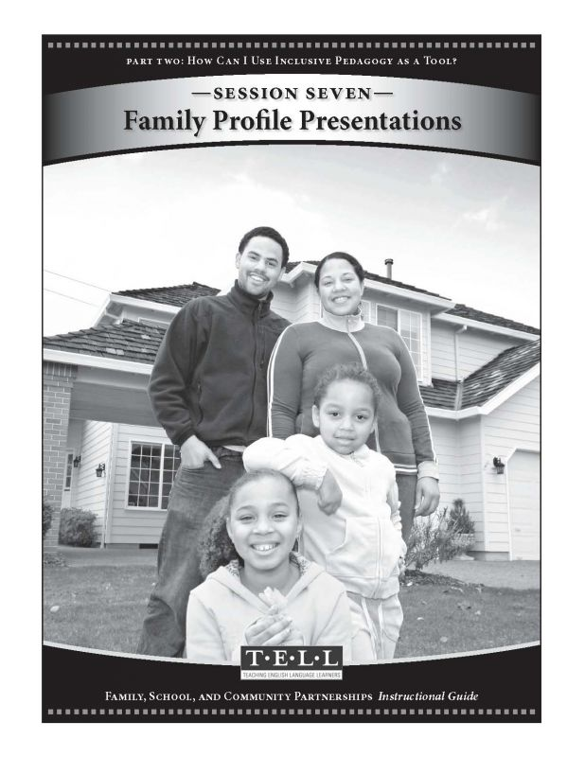
Read this online at https://equitypress.org/partnerships/session_7

